RandomWare Plus+ Installation: Version 4.0

Thank you for your interest in RandomWare.

Contents

1. Uninstall Evaluation Program 2
2. License Agreement 2
3. Support 3
4. Installation from Disc 3
5. Installation from Download 3
6. Installation Continued . . . 3
7. Network Installations 4
8. Default Passwords 6
9. The Help System 6
10. Tutorials 7
11. Program Fonts for the Screen & Printing 7
12. Reports 8
13. Color Control – Setting the Display Properties for you Monitor 9
14. Getting Started 10
15. RandomWare Data Presentations 10
16. Program Short-Cuts 12
17. Some Helpful Tips 14
18. Using the Program 15
19. Opening Data Files 16
20. Re-Installation 17
21. Cover Sheet & Notification Letters 18
22. One Data Set / Two Computers Not on a Network 19
23. Email Resource 19
24. Reduce Random Selection Redundancy 20
25. System Options: Presentation Formats for Random Selection Results 20

Additional Documents
- Uniform Distribution & Random Selection: How fairness is guaranteed.
- Sample Reports

Please visit the website’s support page for additional step-by-step guides for using the software. The new guides are only available online since they are continually updated.

Please visit http://www.randomware.com/pages/support.html
From the website click the Support link: http://www.randomware.com

Uninstall Evaluation Program

If you installed an evaluation system, it is best to remove it before installing the full licensed version of RandomWare. To uninstall, locate the installation folder in the left panel of Windows Explorer and double click it to expose its files in the right panel of the window – locate unins000.exe and double click to uninstall. Then, once again, locate the installation folder in the left panel of Windows Explorer, right click to highlight the folder, and choose Delete. It’s that easy.

After installation, go directly to the Help System by selecting Help from the main menu.
Read After Installation and Getting Started. Review the tutorials to become familiar with essential features of the system.

Microsoft’s Internet Explorer (MSIE) version 4.0 or later is required for the help system to operate correctly. If Help is not accessible, install Internet Explorer 5.0. If it is still not accessible, you may need to run hhupd.exe, another Microsoft Update module. An upgrade to MSIE version 5.01 and hhupd.exe are included on the disc and will be found in the Randomware folder after the installation is complete.

IMPORTANT !

To receive weekly user tips (Tip of the Week) and news about free upgrades, when available, please send your email address to solutions@randomware.com. Email is our primary means of communication.

If you need anything, please let us know.

The installation topics can be found on the web site page at: http://www.randomware.com/pages/support.html

The web site is located at http://www.randomware.com.
From the web site’s home page, select the Support Option at the top of the screen.

License Agreement
RandomWare is the property of RandomWare and is protected by copyright to RandomWare. You, the purchaser only, are hereby granted a single-user or single network installation license to use RandomWare – in general, the license provides for the installation of the system on a single hard drive – local or networked. The license is non-transferable. You may not reproduce, sell, distribute, publish, circulate, or commercially exploit RandomWare, or any portion thereof, without the written consent of RandomWare.

Installation of RandomWare indicates your acceptance of these terms. By purchase, use, or acceptance of RandomWare you further agree to comply with all export laws and regulations of the United States as such laws and regulations may exist from time to time.

The license agreement does not specify an expiration date for the use of RandomWare, however, support is provided by yearly subscription. One year of support is included with the purchase of the license agreement.

No specific warranties exist. However, if any errors are discovered that make RandomWare inoperable, none are known to exist at this time, we will make every effort to remedy the reported error with a program upgrade.

Support

Support is provided through yearly subscriptions and includes updates and upgrades as they become available. Assistance is provided by email or telephone. A one-year subscription is included with the purchase of your RandomWare license agreement. Subscriptions can be renewed for $200.00 year. RandomWare reserves the right to change the subscription rate without notice.

Users should have a general understanding of the Windows Operating system. Support is strictly limited to RandomWare.

RandomWare recommends the following books for information about using Microsoft Windows:
- Running Microsoft Windows 2000 Professional by Craig Stinson & Carl Siechert
- Step by Step Microsoft Windows 2000 Professional
- Step by Step Microsoft Windows XP
- Similar books can be found for Windows 95, 98 & NT

These titles can be purchased at Amazon.com. Significant discounts are easy to find at Amazon.

Installation from Disc

Put the disc in the drive and start Windows Explorer.

To expose the files on the disc, double click the CD icon. To start the installation double click setup.exe where it appears in the right panel of the window.

Installation from Download

Click the URL (internet address) provided in your email or type the address into your internet browser to start the download. See the document about the download procedure for detailed instructions about downloading.

After the download is complete choose the open option to immediately start the installation or save it for installation later. To install on a computer other than the one to which it was downloaded, save the file to a Zip disk or CD and move it to the machine on which it will install.

If you save to install later, use Microsoft’s Windows Explorer to locate and double click the file, RW_Plus.exe, to start the installation.

Installation Continued . . .

Setup will create an installation folder - C:\RandomWare. Specify a different folder if required by your application of the program.

When the installation is complete, the RandomWare icon will appear on your desktop. Double click it to start the program.

Network Installations

Specifying the Network Drive
The installation will allow you to install the system on a network drive of your choice.
Start the installation from a workstation with access to the network drive.

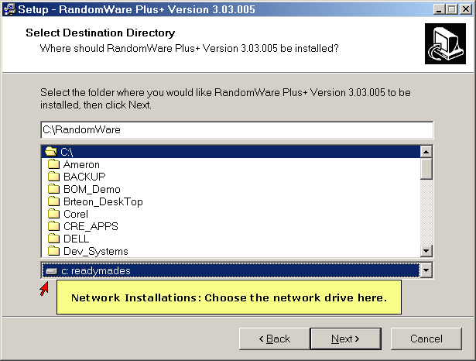

It’s critical that all workstations access the network using the same drive letter, e.g., G: or N:. The program does not allow duplicate Directory file names regardless if the files are in different folders or on different drives.

As a convenience, the previously opened RandomWare Directory is always presented as the “last directory” and can be opened directly when the program starts. If two workstations access the installation folder by different drive letters, a conflict in Directory file names will occur. Consider, for example, two workstations, Workstation #1 (ws-1) & Workstation #2 (ws-2) that access the network drive as G and N respectively. When ws-1 closes a RandomWare Directory, for example, the sample Directory, Dir_Sample, the system will record G:\RandomWare\Dir_Sample as the last Directory, however, G is not a drive accessible by ws-2 and the file cannot be opened when RandomWare is started from the other workstation, ws-2.

Local Scratch Folder
Using Windows Explorer, create a RandomWare folder on the local drive for each workstation. The folder can be named RandomWare or any name appropriate for your application. You must register the folder with RandomWare when the program is first executed from each workstation. For network installations, the program uses this folder for temporary scratch files and a diagnostics file. The diagnostic file is named dw and has no file extension. This diagnostics file is emptied (the file is truncated) and tracks the details of each new session. The file is used primarily as a software development tool and the code that generates the output is not removed prior to its release of the program. The local scratch folder is registered through the Network tab page in System Options. The System Options module is accessed through the Other Data menu at the top of the window when the program starts.

Desktop Short Cuts for Network Installations

When the network installation is complete, copy the shortcut from the desktop of the first installation to each workstation that requires access to the program, or easily create a new shortcut on the desktop of each workstation.

For the steps outlined below, assume the network installation is L:\RandomWare\RandomWare.exe.

To create a shortcut:
- Right click on the desktop.
- Choose New.
- Choose Shortcut.
- Use Browse from the Create Shortcut control dialog box to locate the program installation folder and then the program executable file: RandomWare.exe.
- Click the OK button to finish.
- In Windows 98 L:\RandomWare\RandomWare.exe will appear in the edit box with the caption Command line:
- In Windows 2000 L:\RandomWare\RandomWare.exe edit box with the caption Type the location of the item.
- Press Next.
- RandomWare.exe will display as the name of the shortcut. Rename the shortcut to suit your application of the program.
- Press Finish.

Double click the shortcut to start the program and before anything else, the first requirement is to register the local folder created on the workstation’s local drive as previously explained.

To register the local folder:
- Click the Other Data option from the menu bar at the top of the program window.
- Choose System Options (near the bottom of the menu).
- Click the Network page tab.
- Click the Browse button and locate the folder on the workstation’s local drive that was created using Windows Explorer. When the folder is located press the OK button.
- Click OK from the System Options control.
- Finished.

Default Passwords

Security Access Level I & II:
Administrator Login ID: Admin
User Login ID: User

Default passwords, for both administrator and user, (until modified by the administrator) is Random
Capital “R”, lower case “andom”

Password for Development Access to change Reserved Word/Record Status is lhooq
(LHOOQ in lower case letters). This password cannot be changed.

The Help System

The RandomWare Help System is written using the most current technology from Microsoft. Sometimes, unfortunately, that means there may be compatibility problems with older systems.

Your computer must have Microsoft Internet Explorer version 4.0, or later, installed, or Randomware's Help System may not function properly or may not be accessible at all. Even if you do not access the Internet from the machine on which Randomware is installed, or you use another Internet browser, Microsoft's Internet Explorer must be installed.

If the help system is not accessible and Internet Explorer version 4.0, or later, is installed, follow the instructions outlined in the solution below.

Install Internet Explorer, version 5.01. If the help system is still not accessible, run the HTML update, hhupd.exe, from Microsoft. This has fixed all the trouble we've seen with out of date versions of Internet Explorer. If you still experience trouble, please contact us: Help@RandomWare.com

Microsoft’s Internet Explorer 5.01 update and hhupd.exe are both included with the installation. Both files are copied into the installation folder. Using Windows Explorer, expose the files in the Randomware installation folder and double click on ie5setup.exe to install Microsoft’s Internet Explorer upgrade to version 5.01. Double click on hhupd.exe to update other Internet modules and components.

ie5setup.exe updates your version of Microsoft Internet Explorer to 5.01

hhupd.exe contains Microsoft update modules and components.

The help system continually evolves to improve the explanation of features available in RandomWare and add additional tutorials. Check the web site often for new help modules. If the date of the currently available module is later than yours, please, feel free to download it.

Installation topics and instructions to download a new help module can be found on the web site at: http://www.randomware.com/pages/support.html

Or, go to RandomWare’s home page at: http://www.randomware.com, and select the Support Option.

Tutorials

The tutorials outline the most essential features of the program. Review the tutorials to quickly learn how to get the most out of the resources available.

Program Fonts for the Screen & Printing

You may need to set the print fonts before you can properly print documents through Randomware. The default fonts do not seem to be active for all installations. Print one of the sample Base Lists that accompany the program. If it compares to the print samples included with the installation document, your font settings do not need to be changed.

There are four print font categories:
- Primary Title
- Secondary Title
- Column Headings
- Line Data

And two screen font categories:
- Data Input
- Screen Text (data screen column headings and titles)

When the font control dialog is displayed, set all fonts to Arial, Regular, and Size 8 to insure that all data fits on a page. Be certain the option boxes for “Strikeout” and “Underline” are not checked.

Instructions for setting default fonts are found in the articles in the help system under Printing, Fonts & Colors.

Reports

Additional reports in Adobe Acrobat format (PDF files) are included on the disc. Using Windows Explorer, double click a file to open it in Adobe’s Acrobat reader.

Most installations of Microsoft Windows have a copy of the Adobe Acrobat Reader. If you double click a PDF file it usually opens in the system’s Internet browser.

If your system doesn’t include this resource, it’s available free from Adobe’s website.

To download a copy visit Adobe at http://www.adobe.com. Scroll down the page until you see the link to Get Acrobat Reader. Click and download.

Included Reports

- Directory_Detail: List the details for each directory entry.
- Directory_Summary: List the companies in the directory.
- MIS_Report_Single: General MIS reports for drug & alcohol test results for a single company.
- MIS_Report_Multiple: General MIS reports for drug & alcohol test results for multiple related companies combined in a single report.
- Personnel_Detail: Personnel data sheet.
- Random_Brief: Random selection results listing.
- Random_Detail: Random selection results listing.
- Random_Summary: Random selection results listing.
- Random_WorkSheet: Random selection results listing.
- Roster_Summary: Personnel roster summary.
- Results_Drug_Alcohol: Drug and alcohol test results for an individual.
- Results_Drug_Only: Drug only test results for an individual.
- Results_Alcohol_Only: Alcohol only test results for an individual.

Color Control – Setting the Display Properties for you Monitor

The pre-selected color setting used by RandomWare will display best if the color palette for your monitor is set to a value higher than 256 colors. If more than 256 colors are not available then refer to the Help module for assistance with color control. A screen sample is available on the web site that illustrates what you see if the color palette is not correctly set. Go to Randomware’s support page on the Internet at http://www.randomware.com/pages/support.html to see the example.

To easily access the display control function right click the Mouse  over the“Desktop” and then click “Properties” as shown on the right.  Or access display control from the “Control Panel.”  Once the display control dialog is displayed, select the tab  for “Setting” then a color palette setting greater than 256. |  | 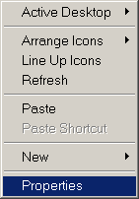

Windows 95/98 will present a dialog box as below.
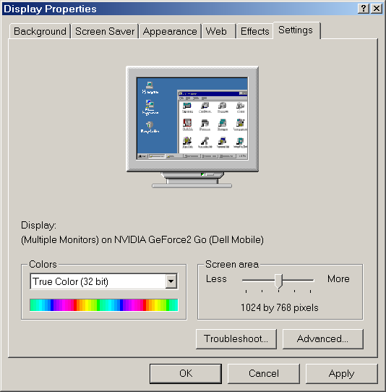

Getting Started

RandomWare provides a variety of directories to manage data:
- Client Directory (multiple)
- CPC or Collectors Directory (single)
- MRO Directory
- Lab Directory
- FYI Directory (.or Your Information)
- TPA Directory (Third Party Administrators)

The Client Directory is the main program resource. You will use it to manage personnel data and drug & alcohol records for:
- Clients, Companies or Company Departments, Groups, Organizations, etc.
- Consortia (Pools)

You can create as many client directories as required by your application of the program. Unless you have very specific requirements, RandomWare recommends that you use a single client directory to manage your data.

All directories, except Client directories, are accessed from the Other Data menu.
If you’re a TPA, use the Client Directory to keep a list of clients for whom you provide services.

If you’re an MRO: Use the Client directory to list to list the companies managed by the TPAs for whom you provided review services. For example, if Acme TPA Services is a client for whom you provide MRO services, you will list all the companies managed by Acme TPA Services and flag each of those companies as belonging to Acme. As an MRO, you can list the TPAs for whom you provide services in the TPA directory (see the Other Data menu).

When the program first starts, click Other Data (see the menu bar at the top of the window) and choose Directories: MRO, Lab, CPC, TPA, FYI. Add entries as needed. Delete (Ctrl-D) any entries not required.

RandomWare Data Presentations

RandomWare is table driven using spreadsheets for viewing and editing data. For many of the RandomWare tables, the row in the spreadsheet is only a partial accounting of the entire record for that table. Multiple views are styled to manage different subsets of the record. For the Directory, Drug and Alcohol Results and Personnel Rosters the entire record cannot be displayed in a single view in a meaningful format. Therefore, multiple views have been defined to help easily manage the data. Select a different view from the Views menu at the top of the window.

You can edit data directly in the spreadsheet or use special editors for full record access. To create a new record, simply scroll down to a new line in the spreadsheet with the down arrow key or insert a new line by typing Ctrl-N. Records in the spreadsheet are deleted by typing Ctrl-D.

Also, you can edit an individual entry with a special record editor. Many tables feature a dialog editor for viewing and editing every field in the record. The dialog editors are divided into tab pages and logically group data for efficient editing. The dialog editors work in conjunction with the spreadsheet. If you scroll to a new entry in the dialog editor, you will see its corresponding record in the spreadsheet displayed behind it.

The special dialog editors are provided for:
- Directory records
- Personnel records
- Drug and Alcohol Result records
- Pool Registry
- Random Selection Audit Trail

Request an editor from special popup menus or by doubling clicking the left mouse button.
- Directory: right click the group name in the Directory and choose the option Edit Directory Entry – All Data [Dialog]
- Personnel Roster: right click a last name for a popup menu and choose the option Personnel Editor. Or, alternatively, double click the last name.
- Results Table: right click an entry’s last name and choose the option Edit Donor Sample Data. Or, alternatively, double click the last name.

Program Short-Cuts

General Information & Help:
Click the question mark to display a page from the help system about the current window in which it’s displayed. Updated help systems are easily downloaded from the web site when additional information and tutorials are added. | 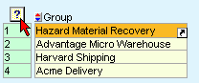

Popup Menu Short Cut:
Left click the “Short Cut” symbol for a popup menu of options available for the current input field.  For example, in the Directory window shown here, click the short cut symbol to pop up a menu for access to data for Hazard Material:  - Personnel Roster  - Drug & Alcohol Results Table,  - Contact Information  - Directory’s Full Record Editor  Optionally, you can right click anywhere inside the current field to access the same popup menu. | 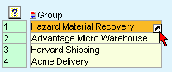

Drop Down Selection:
Click the “Drop Down” symbol for a list of selectable items for the current field.  Note: Some items, such as the type of drug or alcohol test administered, will be completed for you after typing the first letter of the test type. For example, if you type “u” for the drug test administered, the program will complete the entry as “Urine.” | 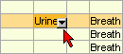
Sorting:
Click the symbol to sort the spreadsheet by the column over which it appears. Click the upper portion for an ascending sort (A-Z) and the lower section for a descending sort (Z-A). Subsequent clicks on the same column reverse the sort. | 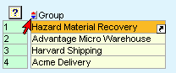

Date Utility:
In spreadsheets, click the calendar symbol to access a utility for date management. Click OK to set the selected date into the current field and close the control. Click Apply to set the selected date and leave the control open. | 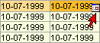
Select an option to control the movement of the cursor after the Apply button is clicked:  - No Action: Cursor stays in the current field  - Up: Cursor advances to the row immediately above the current field.  - Down: Cursor advances to the row immediately below the current field. | 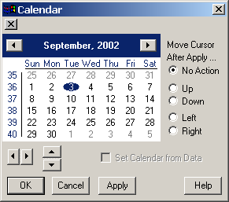
Edit Control Dialog for Data Copy:
RandomWare currently does not offer the standard cut & paste resource familiar to many Windows users, however, the short cut option often provides access to the Edit Control Dialog used for a similar purpose. If the Edit Control option is not available in the popup menu, it can be found in the Utility or Misc menu at the top of the window. Use the edit control dialog to copy a single data item to any number of fields without redundant data entry. For example, easily copy a common employment location to any number of personnel entries.  - Activate the Edit Control  - Click on a field in the spreadsheet to which you want to copy data.  - Type the text in the edit control.  - Click Apply to set the text into the field in the spreadsheet.  - Choose Down from the After Apply options to move the cursor automatically to the next row in the spreadsheet.  - Repeatedly click Apply to copy the text into the next field in the next row. | 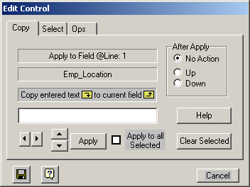

Some Helpful Tips

Dates
- Right click on any date in the system to see its "Day of the Week"

From the Directory Window
- Right click on a Group/Company Name for a Pop-Up Menu of Options.
- From the pop-up menu, select the Dialog Editor to easily access all the data fields associated with each directory entry.
- Double Click on a Group/Company Name to open its Base List (Company Roster.)
- Right click on a Pool-ID for a Pop-Up Menu of Options.
- Double click on a Pool-ID to dynamically combine the member's lists into one for random selection.

From the Base List Window
- Double click on a name to access the Dialog Editor to easily access all the data fields for each employee in the roster.
- Double click on the Mode or Category field to immediately access the Mode/Category manager or right click to access the pop-up menu option that provides access the Mode/Category manager.
- Double click on the Shift field to immediately access the Shift manager or right click to access the pop-up menu option that provides access the Shift manager.

From the Results Data Window
- Double click on a person’s name to access the Dialog Editor to easily access all the donor sample data fields for each entry in the results table.

Using the Program

Random selections are generated from personnel rosters referred to as Base Lists. These lists contain the names and identification numbers of all personnel from which random selections are generated. You can manage as many lists as you require.

Develop groups of lists through the directory facility (Randomware Plus+) or individual lists through a separate management facility.

A Directory is essentially a list of lists through which data is efficiently managed and maintained for pools (consortia), pre-employment data tracking, drug testing data tracking, year to date selection target tracking, random date generation for employee assistance programs, etc., etc.

Randomware provides extensive random selection control as well as comprehensive data tracking for the drug testing industry.

If you provide random selection as part of your drug testing service then maintain a directory of companies for whom you provide testing. Enter each company in a directory, and develop the list for each company entered. Creating a consortium from any number of companies becomes a trivial task with the directory facility and the lists for each individual member can be managed quite easily.

If your company manages its own drug testing program then maintain a directory of the individual departments within your company or a directory for each facility location. List each department in the directory and develop each department's list. If you provide random selections for your organization worldwide then maintain a directory for each location.

A list will correspond to each directory entry and is managed as an individual file. Randomware can manage as many as 100 million (100,000,000) directory entries each with a corresponding list file. The list file names are automatically assigned and the management of each is performed through the directory by the group or company name.

From the directory, simply double click on a group name and the program presents a spreadsheet in which employee rosters (base lists) are maintained.

Random selections are saved to result tables where the results of all drug and alcohol tests are managed. Every data item required for a comprehensive program of drug and alcohol testing is maintained in the results table. Data fields are provided for Medical Review Officer (MRO) information, sample collection information (CPC) and complete drug panel assessments. Refer to the sample result tables for examples of the data managed by the system.

Open the sample directory, Dir_Sample. Once displayed, double click on Acme Delivery to open its base list of personnel. From the program module for base list management, choose the menu option Random to generation random selections.

Click on the text above any column of data to see how easily sorting is managed. For example, move the mouse arrow until it hovers over the text “Last Name” above the column where last names are entered, then click the left mouse button to sort the list by last name. Click again to reverse the sort. From the base list, double click on any personnel entry to access the dialog editor from which all data for an entry is maintained: name, address, phone numbers, notes, comment, etc. Maintain only the data relevant to your application of Randomware.

From the directory window, right click on Acme Delivery and choose Results to open its results table. Once displayed, double click on any personnel entry to access the dialog editor from
which all drug and alcohol testing data can be managed. Once again, maintain only the data relevant to your application of Randomware. Sort data in the same manner described above.

From the Results – Ledger Transfer Utility window, right click on an item in the Trx or Lgr column for access to the Ledger Utility.

Note: Trx is the Transfer pending request column and an “x” displayed in the Lgr column indicates an item has already been transferred to the general ledger.

Opening Data Files

Press one of the Open Directory buttons to open the previously accessed directory, an existing directory or create yet another directory. The first time you use the system, no “previously” accessed directory is defined. From the Open Dialog, select the sample directory, Dir_Sample, for access to the directory facility. From the directory, double click any entry to automatically open its corresponding base list of personnel.

Right click a directory item in the “Group” column to access the group’s results table where all drug and alcohol testing data is managed: Randoms, Pre-Employment, Post-Accident, Reasonable Cause, Periodic and all others.

Open new or existing individually managed base lists and results table with the Basic system menu buttons. From the subsequently displayed Open Dialog, select the sample base list, Sample, to access the base list management environment or open the sample results table, Sample, to preview the drug testing data management features.

NOTE: Randomware Basic does not feature the directory facility. Lists are accessed and managed directly from the menu options.

Base List / Personnel Roster
- To immediately access the complete personnel record editor from the base list window, double click an employee’s name.
- Right click a name or employee I.D. to access the popup menu of options:
- Personnel Editor - or the complete record editor.Create a Drug and Alcohol Results Record Sort Data: Ascending/Descending by column.
- Randomly sort the list.
- Find: Enter any text string or ID to immediately find an entry.

Results Table
- Right click a directory item in the “Group” column to access the group’s results table where drug and alcohol testing data is managed or open the group result table directly from the base list edit window. From the results window, double click an employee’s name to immediately access the complete test result data record editor.
- Right click a name or employee I.D. to access the popup menu of options:
- Edit Donor Sample Data. An editor is presented to manage the entire record for drug & alcohol results.
- Sort Data: Ascending/Descending by column.
- Find – Enter any text string or ID to immediately find an entry.

Re-Installation

It’s easy to move the entire program and all its data to another machine when required. Simply copy the entire installation folder to a zip drive, a Read/Write CD (RWCD), a network drive or a removable hard drive. Copy the saved folder to the new disk drive and create a shortcut on the desktop to the program executable file C:\RandomWare\randomware.exe.

Please Note: The instructions for re-installation assume the default installation folder is c:\randomware. If your installation requires a folder of a different name, please make the appropriate substitutions.

When files are copied from a RWCD, they are written to the target disk as Read Only. If re-installation is performed from a RW CD , the read only property must be removed from all files that were copied.

Removing Read Only

Windows 95, 98

Start Windows Explorer. Locate the installation folder in the panel on the left side of the Explorer window – use the vertical scroll bar if necessary to locate the folder. Left click the folder to expose the sub-folders and all files so they’re displayed in the panel on the right side of the window.

Select Tools, Find, Files or Folders from the Windows Explorer menu bar at the top of the window.

In the Named edit field, enter *.* (the “wildcard” file specification that instructs the find function to locate all files). The installation folder, C:\RandomWare, should already be set in the Lookin dropdown box. If not, use the Browse option to locate the folder. Be certain the box is checked for Include subfolders. Click the Find Now button.

When all files found are displayed in the large rectangle area in the bottom section of the dialog window, click on the first file you see so it’s highlighted. Using the keyboard, press ctrl-a to select all the files displayed. Right click one of the highlighted files and choose the Properties option from the popup menu. In the properties dialog, turn off the Read Only option. The option is off when no check mark is visible. Click on the OK button and you’re finished. The program is ready to run.

Windows Me, 2000, XP

Open the folder where the files were copied. Click on one folder or file to “Set the Focus” to the panel on the right. Select all files and folders by pressing the Ctrl key and typing the character “A” simultaneously. Move the move cursor so it hovers above one of the selected files and press the right mouse button then select Properties. Make sure the Read Only option is not checked. Press the Ok button. Then, when prompted, apply the request to the selected items, subfolders and files.

Cover Sheet & Notification Letters

Print a cover sheet to accompany the random selection report.

The cover sheet summarizes the selection results and reviews the responsibilities required by the specific drug and alcohol testing program.

Print notification letters automatically for each person selected. If the format of the notification letter does not meet the requirements of the application, use the notification data file to print form letters using Microsoft Word's Mail-Merge feature.

The master copies of the Cover Sheet and the Notification Letter are accessed from the Other Data menu option. The documents have specific sections you can edit to accommodate your application of the program.

Every time a random selection is generated, you can edit the text of each section if required by a specific occasion. If you edit the sections from the random selection print control, the changes will persist until reset. A button is provided to reset the text from the master copy.

Mail Merge

RandomWare_Mail_Merge.doc is a Microsoft Word document provided to illustrate the features of Mail-Merge. The text file that feeds this form letter is Orange_County_Taxi_Service.Ntx. These files are found on the installation disc. If you copy the files to your hard disk, you will need to remove each file's Read-Only property. In general, files copied directly from a CD are written to the target media as Read-Only.

The results of every random selection are written to a separate text file. Every data item for each person selected is written to the file including specifics of the selection:
- Drug and alcohol test requirements.
- Location of collection site if specified in the selection including On-Site locations.
- Employee's company name and address.
- Status of an individual's selection: Primary Donor or Alternate.
- Notes and comments entered for the individual. These notes are recorded in the personnel roster.

The notification data files are written to the installation subfolder Notice. You will find subfolders under Notice named for specific selection dates. The subfolder names appear in the format mm/dd/year. The notification data files are found in these folders. The files are named identically as the personnel roster if you're using the Basic system or identically as the company is entered in its respective RandomWare Directory. The notification files as assigned the extension .NTX. If the random selection was from a Pool or Consortium then multiple files will be found. One file, named identically as the Pool, will list all individuals selected and one file for each member of the consortium represented in the selection. No data will exist for a consortium member that did not have representatives selected. Printing notification letters using the Mail-Merge feature is outlined in the help system. Start the help system, click the Contents tab, double click the Help System Overview book to list its topics and click the page titled Notification File & Mail Merge. Mail Merge can be used to print envelopes and labels. A separate data file is created that contains the address of each company for whom a random selection was generated. An address file is also generated for multiple envelopes or labels when generating selections from a consortium. The address files use the extension .ADR.

One Data Set / Two Computers Not on a Network

If you require the use of two computers to manage one set of data for a RandomWare application, it is necessary to completely copy all RandomWare related files from the computer with the most recent activity to the intended or target computer. Concurrent use of two computers, not on a network, and one data set is not possible - there is no mechanism to adequately manage the data between the two.

A RandomWare "Distribution" system is planned for future release. The distribution system will allow for the exchange of data between two computers, a "Host" and "Field" system, so an application can manage data in the field and update the host resident data set at the end of the day.

An Ethernet connection is an easy method to transfer the RandomWare data set from one machine to another.

Purchase an Ethernet "PC" card for a laptop computer for as little as $35.00 and an Ethernet card for a desktop for as little as $15.00. Ethernet cards with the fastest throughput are typically referred to as "10/100M Ethernet Cards." Typically, computers are connected via an Ethernet hub, however, you can directly connect two computers without a hub and eliminate the expense of the extra piece of equipment. If you connect the machines directly, you will need a "Cross Over" cable instead of the standard Ethernet cable. A "Cross Over Cable" literally provides a cross over connection.

Cross Over Cable

Consider a connection that requires two wires for communication: Wire #1 is output and Wire #2 is input. When a hub provides the communication, it receives all input on Wire #1 from all computers connected and transfers the output to the intended computer on Wire #2. If two computers, A & B, are connected without a hub, then Wire #1 of computer A must connect directly to Wire #2 of computer B and conversely, Wire #1 of B connects directly to Wire #2 of A. This is exactly what a "Cross Over" cable provides.

When the connection is complete, use Windows Explorer to copy the installation folder from one computer to the other. For example, if RandomWare is installed in the folder, RandomWare, on the "C" drive of both machines, then right click the folder on the computer with the most recent activity, drag it to the intended computer and drop it on its corresponding "C" drive. The operating system will respond with a message that a folder of the same name exists and asks if you want to overwrite. Answer "Yes" or "Yes to All" to continue. The target computer will have an exact copy of the RandomWare data set when the operation is complete.

If a Ethernet connection is not possible, the transfer can be accomplished in exactly the same way using an intermediate storage device, e.g., a zip drive, a CD/RW disc or an external USB hard drive.

Email Resource

Please note, although the email resource is included in this release, it is still under development. Documentation and support for its use is currently unavailable. You will receive an email when the resource is finished and the help system is complete.

If you have any questions, please feel free to call.

Reduce Random Selection Redundancy

You can reduce redundant random selections without bias. To learn more about this feature, open a personnel roster, click the Randoms menu at the top of the window and choose the Random Selection Preview option near the bottom of the menu. When the dialog box is displayed, click the Help button to learn how the feature works.

If you’re generating a Random selection for a consortium, you can reduce the number of personnel randomly selected from any single member of the consortium. To review this feature, open the sample directory, Dir_Sample, and double click one of the Pool IDs (Pool_1A or Pool_1B) to dynamically combine the personnel rosters for its respective members. Click the Randoms menu and select Random Selection Preview near the bottom of the drop down menu to review this feature.

These methods are completely unbiased; yet provide a means to reduce the redundant testing of personnel. Random Selection Preview is an optional resource and selections can be generated without the use of the preview method. The preview and non-preview methods both record the results of the random selection identically, however, the preview method does not record the selection until you decide to use the previewed results.

System Options: Presentation Formats for Random Selection Results

The results of random selections can display in a spreadsheet that looks exactly similar to the roster from which the selection was generated. Alternatively, the results can display in a dialog box with buttons to easily access the options available. The latter method is recommended.

Please be sure your system options are set correctly for the best presentation of random selection results.

Access System Options from the Other Data menu: click Other Data + System Options to present the System Options dialog.

Note: The Other Data option is found in the menu bar at the top of almost all program windows.

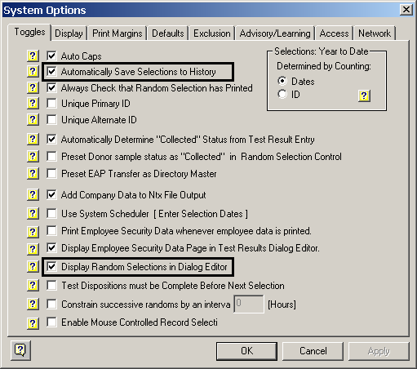

The options checked above:

- Auto Caps: The first character of every word is automatically capitalized (spreadsheet data entry only).
- Automatically Save Selections to History: The results of the random selection are automatically saved to the personnel roster’s corresponding results table. If the table contains data, the results are appended to the end. If the table does not exist, it’s created and the results are added to it.
- Always Check that Random Selection has printed: A message is provided so the user has an opportunity to print the results if the close button is clicked before a print option has been selected.
- Automatically Determine “Collected” Status from Test Result Entry: Results entered as Positive or Negative automatically set the donor sample as “Collected” – only samples flagged as collected are counted in MIS reports.
- Add Company Data to Ntx File Output: (Plus System) The group’s address data is added to each random selection result record output to the notification file. Notification files are tab delimited data files that can be used with Microsoft Word’s Mail-Merge feature to generate customized notification letters.
- Display Employee Security Data Page in Test Results Dialog Editor: Check this option to include the security data tab page when editing drug and alcohol testing data in the full dialog editor.

Display Random Selections in Dialog Editor: If checked, the results of the random selection are displayed in the dialog box as shown above, otherwise, the results display in a spreadsheet.

Spreadsheet Display

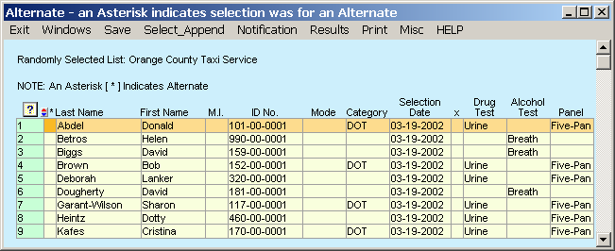

When the selection results display in the spreadsheet format, printing is controlled from the menu bar at the top of the window. Only the summary report can be printed from the spreadsheet, while the dialog presentation provides options to print all the formats including the cover sheet (Plus System) and notification letters.

Dialog Display

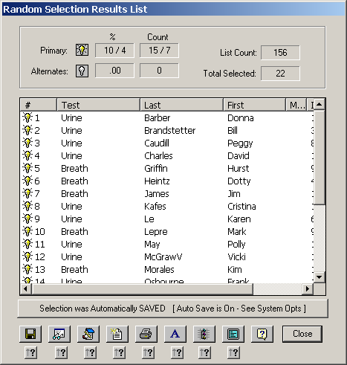

Click the printer button to choose a print format.

Click the Font button to change font characteristics. Most reports were designed to fit on the page using Arial, Regular, 8. Title-1 & Title-2 can be set to Arial, Bold, 8.

Print Fonts are controlled on the second tab page of the font control dialog.

