RandomWare Update Installation: Version 4.01.018

The installation provides enhancements to earlier systems and fixes reported errors.

Contents

1. Installation from Disc 2
2. Installation from Download 2
3. Correctly Installed Update 3
4. Email Resource 5
5. Backup your Data Before Installing Updates 6
6. Errors Fixed with the Update & Data Resolution 6

IMPORTANT INSTALLATION NOTE

We have recently learned that installations must be restricted to a folder directly under the root.

For example: C:\RandomWare

Do not install the system under another folder, for example: C:\Program File\RandomWare

If you install the program on a network drive, be certain to install it directly under the root of the intended drive. For example: N:\RandomWare

A message will be posted on the website when this limitation is resolved. http://www.randomware.com/pages/support.html

Check the website for news or send an email to ask about its resolution.

mailto: solutions@randomware.com

If you have questions about the program or need assistance with the installation, please feel free to contact me at your convenience.

Sincerely,

Luciano Gonzales for RandomWare

(323) 793-1535

8:00am – 6:00pm (PST)

Installation from Disc

Files on the disc:
- setup.exe – Update installation program – Installs RandomWare 4.01.018 as an update to an existing installation.
- RandomWare.exe – This is the program executable – it’s provided for easy access if required.
- Randomdx.txt – RandomWare’s program definition file – it’s provided for easy access if required. This file is installed in the DBF folder.
- Random.chm – Main help system.
- Tutorials.chm – Tutorial help system.

Insert the CD into the drive and start Windows Explorer.

To expose the files on the CD, double click the icon that represents the CD drive on your computer. To start the installation double click setup.exe where it appears in the right hand panel of the window.

Installation from Download

Click the URL (internet address) provided in your email or type the address into your Internet browser to start the download. See the document about the download procedure for detailed instructions about downloading.

After the download is complete choose the open option to immediately start the installation or save it for installation later. To install on a computer other than the one to which it was downloaded, save the file to a Zip disk or CD and move it to the machine on which it will install.

If you save to install later, use Microsoft’s Windows Explorer to locate and double click the file, RW_Plus_Update_4_1_18.exe, to start the installation.

Correctly Installed Update

By default, the installation automatically installs the update into the original installation folder.

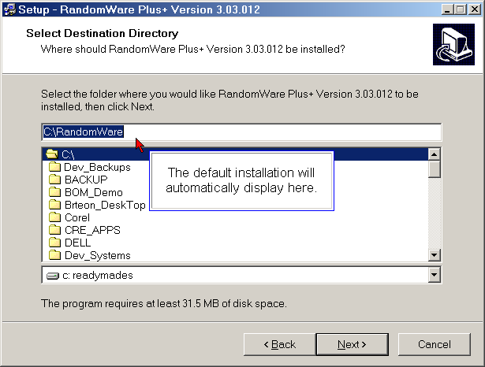

If you installed the program into a folder with a different name, moved or renamed the folder, see the example below.

BEWARE: Do not allow the program to create an installation sub-folder as illustrated below.

If you browse and select an existing folder, the installation adds a subfolder specification to the path, “\RandomWare”, and will incorrectly install the update into the new subfolder. This is an incorrect installation.

Do not browse to select the existing RandomWare folder.
NOTE: A folder is “selected” when it appears “Open” as shown below.

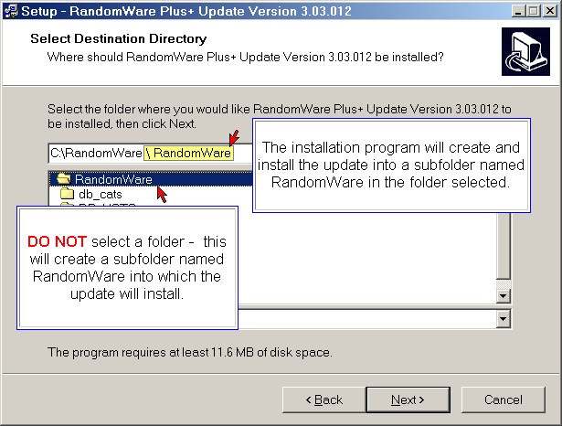

If the program was originally installed into a folder of a different name (not RandomWare) its name will automatically display as the default installation folder.

If the installation folder was moved or renamed and you need to browse to find it, be certain to delete “\RandomWare” from the edit control as shown in the example on the next page. If you don’t delete the subfolder specification from the installation path in the edit control, as shown below, the update will not install correctly.
Locating the Installation folder with the Browse Option

If you browse to select an existing folder, the installation appends the selected folder with “\RandomWare,” as shown below, and indicates a subfolder named RandomWare will be created and the update will install into it. If you browse to select a folder, be certain to delete the “\RandomWare” from the edit control as shown below:

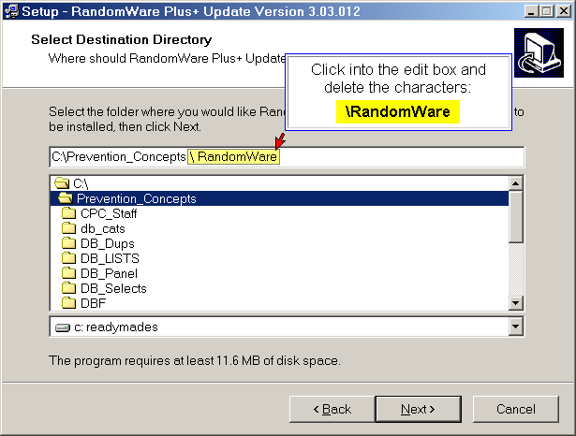

To continue the installation, click Next.

Email Resource

Please note, although the email resource is included in the update, it is still under development. Documentation and support for its use is currently unavailable. You will receive an email when the resource is finished and the help system is complete.

If you have any questions, please feel free to call.

Backup your Data Before Installing Updates

RandomWare does not have a built in backup facility. The best backup method is to simply copy the entire installation folder to another folder on the hard drive or to another hard disk: local, external or a network drive. Alternatively, you can copy the installation folder to a CD or a Zip disk.

Errors Fixed with the Update & Data Resolution

Versions of the program prior to this update did not bind manually entered drug and alcohol records to their respective directory entry (Group or Company).

Note: Manually recorded drug and alcohol records are those not created through the random selection process:
- Pre-Employment
- Post Accident
- Follow-Up Testing
- Reasonable Suspicion
- etc.

Follow the steps outlined below to bind these records to their respective directory entry:
- Open the Directory
- From the top of the window click the menu options:
  - Results_Mgt
  - Review Results for Entire Directory
  - All Records – Exclusive Access

Locate all records with a Reason for Testing not listed as RND (Random) - see the data under the column heading: Test Reason.

If you scroll through an entry that’s not properly bound to a directory entry, the Directory Selection dialog will display. Select the directory entry to which the record belongs.

Optionally, you can assign a directory entry through the full record editor:
- Double click the Donor’s last name to display the Full Record Editor.
- Click the tabbed page labeled Misc.
- The field titled Group (lower left corner) will be blank.
- Click the Assign to Group button and select the directory entry to which the record belongs.
- Click the Apply or OK button to register the modification.
A record in the editor is a copy of the data in the spreadsheet.
Both the Apply and OK buttons save the data modifications to the spreadsheet. Click OK to record the modifications and close the editor. Click Apply to record the modifications without closing the editor.
- At the far right and along the bottom edge of the dialog editor you can click the up or down buttons to scroll to the next or previous record. Alternatively, you can close the editor and scroll through the spreadsheet to another record.
- When you’re finished, click the Save (Save Data) option from the menu bar at the top of the window to permanently save the data modifications to disk.

